Hay Town Council

Hay Town Council
Council Offices
Recreation Facilities
Brecon Road
Hay-on-Wye
HR3 5DY

01497 808019
townclerk@haytowncouncil.gov.uk
www.haytowncouncil.gov.uk

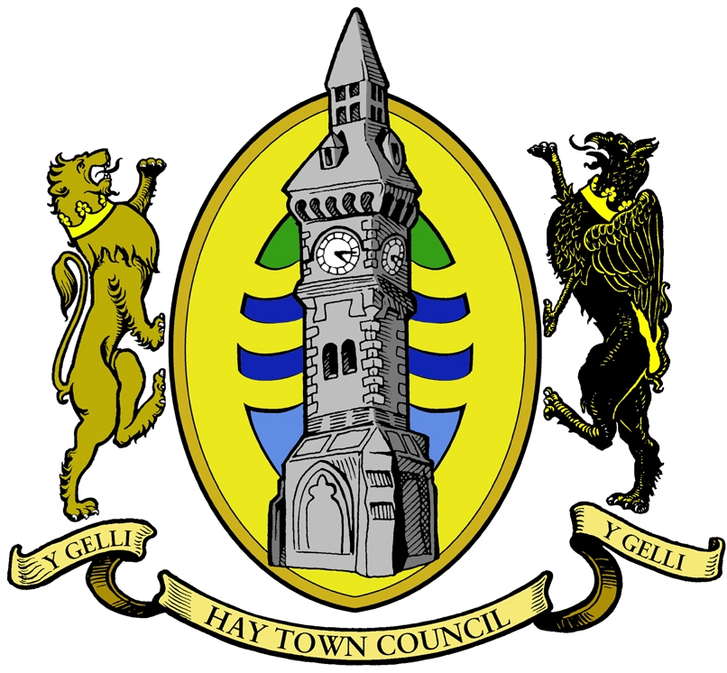
-
#
#####

Draft Minutes for the meeting of Hay Town Council on Monday 3rd June 2024 at 6.00pm
in the Council office, Brecon Road, Hay on Wye, HR3 5DY.

Please note, under the new Local Government and Elections (Wales) Act 2021, Councils are required to provide access to remote meetings for members of the public and the press. If you would like to access the meeting remotely, please see details at the bottom of the agenda on how to join via the Teams platform

- Apologies for absence
Present: Cllr S Morris, Cllr R Golesworthy, Cllr J Morgan, Cllr G Williams, Cllr J Prothero, Cllr P Jenkins, Cllr A Bielski.
Also present: Clerk C Bunton, Cllr G Ratcliffe;
Apologies: Cllr F Howard, Cllr A Powell, Cllr J Hall, Cllr W Bielska.

- Declarations of Interest & Code of Conduct
AP – HADSCAL, The Warren, Hay Woodland Group
FH – HADSCAL, Cheesemarket, Castle Trust, The Warren & proposed cycleway, Christmas lights testing, Northwier Trust, Gwynne’s Almshouses, Hay Swimming Pool, Clifford Primary School.
RG – The Warren, Cheesemarket, Hay Swimming Pool.
JP – Member of St Mary’s Church.
SM – 1st Hay on Wye Scout Group, Radnor Explorers, Summer Show, owner of business in Hay, Country Supplies & Post Office, ATM.
JM – Hay Woodland Group, Hay Warren Anglers, Repair Café.
JH – Xms Lights.
PJ – Hay Primary School, Northwier Trust, Welsh Liberal Democrats, Senedd - Jane Dodds MS
AB – Repair Café.
WB – Chemist.
GW – Hay & Brecon Farmers.

There was some discussion around Cllrs declaring if they were affiliated to a particular party. I was noted that Hay Town Council is Apolitical and as in independent entity as a whole is not affiliated with any political parties.

- Questions from Members of the Public
None

- Minutes of the meeting dated 15th May 2024.
Agreed as a true and accurate record and signed

- Fly tipping Warren Close
Has not yet been removed. Powys CC has investigated and as the land is owned by HTC it is our responsibility. Letter to be written to all residents on Warren Close. PJ to arrange a litter pick.

- Community Car Parking during Festival
Overall it was a success with community groups raising reasonable amounts. Discussed possible ways of sharing the money out so more even and trying to ensure that all have card readers. HTC have received Thank you’s from all the groups involved.

It was noted that people commented had food been served it would have been better, however this would have needed extra toilet provision.

- General parking during Festival
Powys CC have been contacted as Cllrs were concerned that people were being ticketed without being aware that Church Street had become no parking on the one side. An enforcement notice had been placed on the lamp post along with a number of other posters however no cones had been placed out. Powys CC notified HTC that the cones were Festival’s responsibility.

40 spaces in the main car park, Oxford Road were taken up with coaches. Mini and Midi buses on the schools days parked on Recreational Field. Clerk to invoice the Festival.

- Phone signal during Festival
The whole of Hay struggled for phone signal during the festival. Only Vodafone worked with any degree of reliability. This impacted on the ATM, Nayax card payments on the toilets and mobile card readers for businesses.

- Bailey Walk Embankment
JM & CB to write and clarify situation.

- D – Day 80th Anniversary
Cllr A Powell will not be able to wear the chain. Cllr A Bieleski to wear the chain. RBL & Castle have agreed plans. Service starts at 9pm Beacon will be lit at 9.15pm with a short service.
Kelvyn Jenkins will be playing the last post at 9am
Town Crier will read statement at 10am

- Millbank
Powys CC and BBNP have been written to. Awaiting responses.

- Subcommittee Reports / Minutes
- Finance
Accounts are still with the auditor. Additional Full Council meeting will be held on 27th June 6.30pm to ratify the accounts.
- Date of next meeting – 7th June.

- Estates
- Cemetery
Powys CC are unable to do anything as now in perdah.
Cllr Gareth Ratcliffe agreed to meet with Cllrs for a soft launch of the cemetery. SM to book photographer.
- Estates survey
Completed.
- Car parking area.
Awaiting on start date notification.
- BBNP Funding Meeting
JM has completed the letter.
- Stolen Heron
Woodland Group will be starting a crowdfunding page to replace the stolen wood carving.
- Tennis Courts
Members of the Tennis Club have contacted Cllr FH. Meeting to be arranged. Clarification of ownership of nets. CB to write to Steve Butcher.
- Date and time of next meeting - TBC
- Premises
- Clock Tower Toilets
No problems at the moment.
- Oxford Road Toilets
Paddlegates are major issue. Danfo investigating options.
- Pavilion
It was noted that after raising with Clubs lights are still being left on.
- Date and time of next meeting - TBC
- Communications & Events
- Hay Summer Show
WB & AB will be running the HTC stall. Other Cllrs more than welcome. Please can Cllrs donate bottles.
- Date and time of next meeting – TBC.

- Report of the Clerk / RFO
- Bank Reconciliations
Previously circulated. No questions were raised.
- Additional meeting will be needed to sign off annual accounts, previous covered.
- Training. Code of Conduct training to be booked. Spare places to be offered to Llanigon, Clyro and Glasbury Community Councils.
- Major Correspondence
- Bus Network – Cllr G Ratcliffe will be inviting representatives from local councils to come together and give their feedback.
- ATM – Barely worked during the festival due to signal issues.

- Reports of HTC Representatives:
- Gwynne’s Almshouses - none.
- Dial a Ride – none.
- Dyfed Powys Police – selection of emails forwarded out to Cllrs.
- OVW – AGM in Builth 2nd July.
- Cheesemarket – none.
- Hay2Timbuktu – none.
- BBNP – none.
- Chamber of Commerce – have requested that a sign is made explaining why toilets cost 30p
- Hay Summer Show – next event is live music in the Parish Hall. 17th June.
- Hay Markets – none.
- Hay Youth Club – none.

- Date and time of next meeting:
Monday 1st July 2024.

Any Other Business:
Junior Football did exceptionally well and won 3 cups. Council to write and congratulate.

Cllrs FH & SM to arrange Thank you to Cricket Club.

Potential apologies had been received for County Cllr Gareth Ratcliffe, so no agenda item was given however Cllr Ratcliffe reported that he had been asking questions regarding the missing £7.2m for Gwernyfed High School.
BT switch over is currently on hold.
Complaints have been received about speeding vehicles on Newport Street.
Football is intending to return to a Community Club.
Cllr GR to ask Powys CC regarding loss of income on car parking due to buses.

Meeting closed 7.42pm

